<https://bookshelf.vitalsource.com>

<https://www.aws.training/UserPreferences>

**Account ID:** yccL4NJeBU2TP85othrEGg2

My Account

<https://aws.qwiklab.com/focuses/58037#lab-1-build-your-vpc-and-launch-a-web-server>

485669587219

awsstudent

nS9bFhj4q

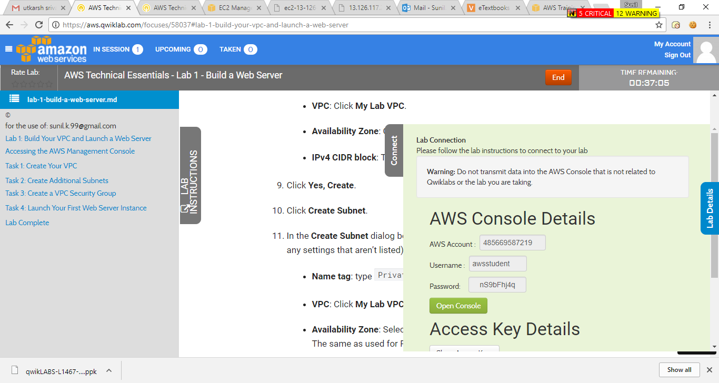

EC2 Elasctic complute Cloud

Resizable

Reduced time required

<https://www.aws.training/oneclickregistration?id=12820>

AMI

Instance type ------Virtual hardware

GP :- general Pur.

EC2 Lanch

EC2--🡪 AMI -> CPU/MEM -> Network IP Securty

AMI :- Amazon machine Image

Publicly

Implect

Storage type :-

Instance Storage :- local hardisk

EBS : - SAN storage / EBS

Metadata Information :-

<http://169.254.169.254/latest/meta-data/>

USER-DATA

<http://169.254.169.254/latest/user-data/>

EC2 purchasing :-

On-Demand instance

RI (Reserved Instance)

Scheduled Instance

Spot Instance

Dedicated Instance

Dedicated Hosts

2VCPU = 1 Phy. Core

VPC :- Provision a private , nacl virtual network , route table create , create subnet

<https://407005644379.signin.aws.amazon.com/console>

S3 ---Create Bucket

Standard

IA

RR

Glacier

HDDC & SDDC differ

Three Module of cloud computing

IAAS

PAAS

SAAS

VPC

CIDR

VPC --🡪 Subnet🡪 IGN-🡪 NaT GATWAY 🡪 Route table (custom )

Public is called IGN

Private is called nat gatway

EBS

SSD better speed

Magnetic Too much latency

========================================

100 Bucket create in a single S3.

Public Subnet

ELB

NAT Gatway

Bash HASH

VPC flow log is enabled

Two VPC in differ region is not be make peer . Peer only happen in same AZ

Route 53